 | SIDBI sponsored Skill-cum-Technology Upgradation Programme on  Improved Production Technologies of  Medicinal and Aromatic Plants | PHOTO
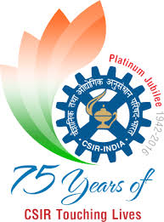

Venue: CSIR-CIMAP Research Centre, Bengaluru
Date : 27-29 July, 2017

REGISTRATION FORM
- Name :

- Father’s Name :

- Date of Birth :

- Educational Qualification :

- Category : Gen/OBC/SC/ST

- Religion :

- Present Address :

- Phone/Mobile No. :

- E-mail :

- Name of organisation/ :
Individual & Address

- Description of land for :
Cultivation (Acre/ha)

- Annual Income :

- Any other information, if any :

- D.D. No. (for official use) :

Place:
Date: SIGNATURE

Note: Please attach a valid Photo ID

